**AI Financial Advisor**

Empowering Smarter Financial Decisions with Gemini

The AI Financial Advisor is an intelligent personal finance application powered by Google’s Gemini 2.0 Flash generative AI model that provides personalized, data-driven financial insights in real time. It allows students, professionals, and retirees to plan budgets, track expenses, manage investments, and receive customized financial advice all through an intuitive, AI-assisted dashboard.

This system bridges the gap between financial literacy and automation by understanding a user’s financial profile including income, expenses, debts, and goals and producing strategic, actionable insights for better money management.

**Scenario 1: Personal Financial Planning and Analysis**

Working professionals and students can use the AI Financial Advisor to gain a holistic understanding of their financial health.

By entering details like **income, monthly expenses, existing savings, and financial goals**, users can instantly view their **budget ratio**, **savings rate**, and **debt-to-income ratio**.

The Gemini model then analyses this data and generates tailored recommendations such as:

* How to increase monthly savings
* Best allocation between savings, investments, and spending
* Emergency fund and risk management suggestions
* Investment ideas (ETFs, SIPs, or mutual funds)

For example, a user earning ₹60,000 per month with ₹35,000 expenses and a ₹10,000 debt can receive an automated plan suggesting how to balance loan repayment and SIP investment to achieve long-term financial stability.

This helps individuals make informed decisions, maintain financial discipline, and build a sustainable wealth strategy.

**Scenario 2: Goal-Based Planning and Smart Investment Strategy**

The AI Financial Advisor can serve as a **personalized financial planner** for users with specific goals such as:

* Buying a house
* Building an emergency fund
* Planning for retirement
* Saving for education or travel

Once users input their goals and timelines, the AI design **custom goal plans** with estimated savings requirements, investment distribution, and progress tracking suggestions.

For instance, if a user aims to save ₹5,00,000 in 3 years, the system calculates monthly saving targets, recommends a balanced portfolio, and generates a strategy that adjusts based on income or expense fluctuations.

This use case demonstrates how AI can help individuals achieve long-term financial independence while adapting to changing life circumstances.

**Architecture**

The AI Financial Advisor follows a modular, multi-layered architecture integrating Google’s Gemini 2.0 Flash API, Streamlit UI, and data analysis tools like Pandas, NumPy, and Matplotlib/Seaborn, and environment management via dotenv for secure configuration.

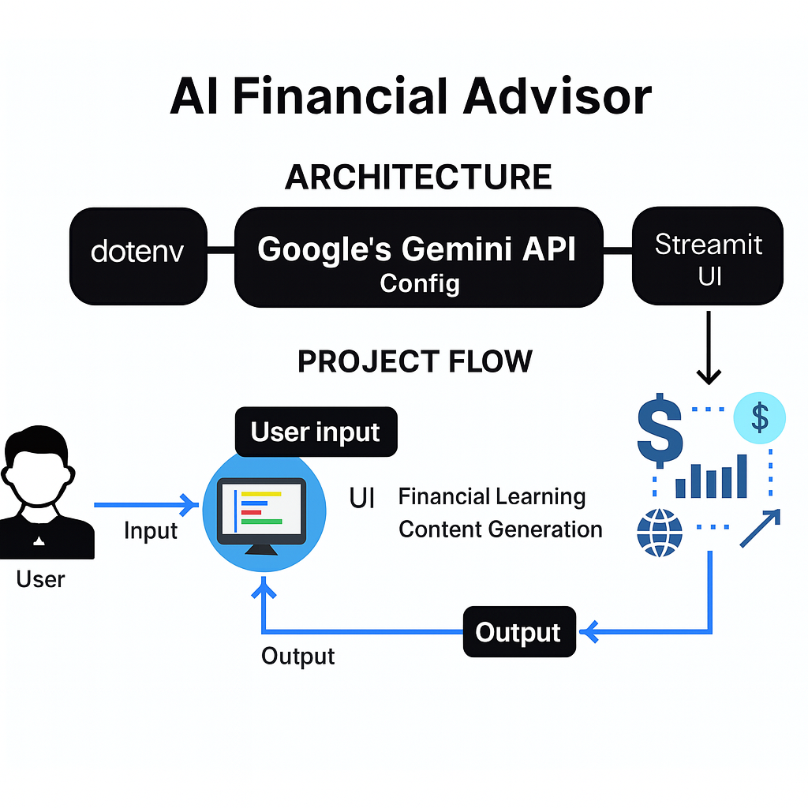

**Project Flow:**

1. **User Input Collection**: Users securely input their comprehensive financial details through an intuitive Streamlit interface, including income sources, expense categories, debt obligations, existing savings and investments, financial goals, and personal risk tolerance preferences.
2. **Advanced Financial Analysis**: The application performs sophisticated financial health assessment using the analyse_finances() function, which calculates key financial metrics, evaluates debt sustainability, determines investment capacity, and assesses overall financial stability.
3. **AI-Powered Advisory Generation**: The system leverages Gemini AI through the generate_financial_advice() function to create personalized, context-aware financial recommendations that align with the user's specific financial situation and objectives.
4. **Strategic Goal Planning**: Advanced goal-oriented financial planning is facilitated through the generate_goal_plan() function, which incorporates user-specific instructions and preferences to create customized financial roadmaps with clear milestones and actionable steps.
5. **Interactive Visualization**: Dynamic, interactive charts and comprehensive metric displays provide users with clear visual representations of their financial health, progress toward goals, and the impact of different financial decisions.
6. **Intelligent Chat Support**: An AI-powered financial chatbot offers instant, intelligent responses to user queries, providing clarification, additional information, and context-specific financial guidance.

**To Accomplish This Project, You Must Complete the Following Activities:**

* Install and configure all required libraries and APIs.
* Initialize the Gemini model.
* Develop the brand learning and content generation functions.
* Build the Streamlit user interface.
* Deploy the complete application using Streamlit.

**Prior Knowledge**

You should have an understanding of:

1. **Google Generative AI (Gemini)**

Google Gemini provides advanced generative AI models for natural language understanding and content generation. Knowledge of interacting with the Gemini API, configuring models, and sending structured prompts is essential.

Official Documentation:[**https://cloud.google.com/gemini/docs?utm_source=chatgpt.com**](https://cloud.google.com/gemini/docs?utm_source=chatgpt.com)

1. **Streamlit**

Streamlit is a Python-based framework for building interactive web applications.Understanding widgets, forms, layout management, and state handling is crucial for building the frontend.

Official Tutorials:[**https://docs.streamlit.io/develop/tutorials?utm_source=chatgpt.com**](https://docs.streamlit.io/develop/tutorials?utm_source=chatgpt.com)

1. **Environment Management**

The python-dotenv library allows secure management of environment variables such as API keys. Ensures sensitive credentials are not exposed in your code.

Official Documentation:[**https://pypi.org/project/python-dotenv/?utm_source=chatgpt.com**](https://pypi.org/project/python-dotenv/?utm_source=chatgpt.com)

1. **Prompt Engineering**

Prompt engineering is the process of designing and structuring input prompts for AI models to produce accurate, high-quality output. Knowledge of crafting clear instructions, templates, and examples helps the AI understand context, tone, and desired output format.

Learning Resources:[**https://platform.openai.com/docs/guides/completion/prompt-design**](https://platform.openai.com/docs/guides/completion/prompt-design)

[**https://www.datacamp.com/blog/prompt-engineering**](https://www.datacamp.com/blog/prompt-engineering)

1. **Python Programming**

Core Python skills are essential for integrating the AI model, handling data, and building backend logic. Knowledge of libraries like os, pyperclip, typing, and API interaction using Python is required.

Official Documentation:[**https://docs.python.org/3/**](https://docs.python.org/3/)

**6. Regular Expressions (re Module)**

Regular expressions are powerful tools used for pattern matching, text cleaning, and data validation in Python. They allow developers to search, extract, and manipulate complex text patterns efficiently, such as validating emails, cleaning unwanted symbols, or parsing log files.  
  
Official Documentation:

[**https://docs.python.org/3/library/re.html**](https://docs.python.org/3/library/re.html)

**7. Data Analysis Libraries**

**Pandas:** Pandas is a flexible data manipulation library that provides high-performance data structures like DataFrames and Series for handling tabular data.  
It simplifies tasks like reading CSV/Excel files, cleaning datasets, and performing grouping or aggregation operations.  
  
Documentation:

[**https://pandas.pydata.org/docs/**](https://pandas.pydata.org/docs/)

**NumPy:** NumPy is a fundamental library for numerical and scientific computing in Python. It provides efficient support for multi-dimensional arrays, mathematical operations, linear algebra, and statistical functions. NumPy forms the backbone of most AI and data science libraries, including Pandas, TensorFlow, and Scikit-learn.

Documentation:

[**https://numpy.org/doc/**](https://numpy.org/doc/)

**8. Data Visualization**

**Matplotlib:** Matplotlib is a comprehensive library for creating static, animated, and interactive visualizations in Python. It offers fine-grained control over plots, allowing users to build customized charts for financial, scientific, or statistical analysis.  
  
Documentation:

[**https://matplotlib.org/stable/contents.html**](https://matplotlib.org/stable/contents.html)

**Seaborn:** Seaborn is a high-level data visualization library built on top of Matplotlib, designed to make plotting more attractive and simpler.  
It offers built-in themes and statistical plotting functions that automatically integrate with Pandas DataFrames.  
  
Documentation:

[**https://seaborn.pydata.org/**](https://seaborn.pydata.org/)

**Project Structure**

This project can be developed on VS code editor with Python 3.11.3.

**The final structure looks like this:**

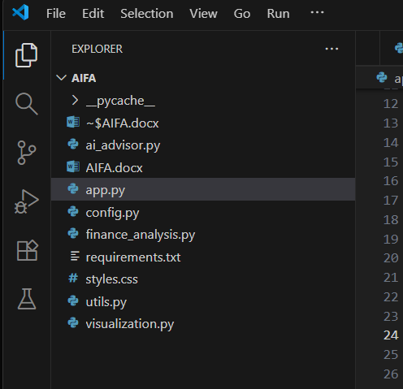

**Milestone 1: Requirements Specification**

**Milestone: Library Installation and Setup**

This milestone ensures all necessary libraries are installed and configured to run the AI Financial Advisor App. It sets up the environment for data analysis, visualization, secure API integration, and interactive user interfaces using Streamlit.

**Option 1: Install Required Libraries**

The following libraries are needed:

1. **Streamlit**: For creating an interactive web-based financial advisor interface.
2. **google-generativeai**: Used to connect with **Google Gemini API** for generating AI-driven financial insights.
3. **Pandas**: For efficient data manipulation, analysis, and tabular data handling (CSV/Excel).
4. **NumPy**: Provides numerical operations and supports mathematical computations for financial model.
5. **Matplotlib**: Used for static, animated, and interactive financial visualizations.
6. **Seaborn**: Simplifies statistical data visualization with clean and modern aesthetics.

**Installation Command:**

pip install streamlit google-generativeai pandas numpy matplotlib seaborn

**Option 2: Using requirements.txt for Library Installation**

This approach ensures **reproducibility and easy setup** for all users by installing all required libraries at once from a requirements.txt file.

**Steps**

1. **Ensure requirements.txt Exists**  
   The project folder should contain a requirements.txt file with the following content: streamlit, google-generativeai, pandas, numpy, matplotlib, seaborn
2. **Install All Libraries**  
   Run the following command in your project directory to install all dependencies at once:

pip install -r requirements.txt

**Explanation of Each Libraries:**

* **Streamlit:**  
  Provides a simple and fast way to build interactive web applications for AI and data-driven projects without needing front-end development skills. It powers the user interface of the AIFA app.
* **google-generativeai:**  
  Connects to Google’s Gemini API to generate personalized and intelligent financial insights, advice, and text responses based on user data and goals.
* **Pandas:**  
  Used for data manipulation and analysis, allowing efficient handling of tabular data such as income, expenses, and savings. It simplifies financial data processing and reporting.
* **NumPy:**  
  Enables numerical computations and mathematical modeling, supporting operations like budgeting calculations, ratios, and predictive analysis.
* **Matplotlib:**  
  A powerful visualization library for creating static, animated, and interactive financial graphs such as spending trends, investment growth, and savings distributions.
* **Seaborn:**  
  Built on top of Matplotlib, Seaborn simplifies the creation of clean and visually appealing statistical charts, helping display financial insights with clarity.
* **re (Regular Expressions):**  
  Used for text pattern matching, cleaning, and validation, ensuring accurate user inputs and preprocessing financial text data.
* **os:**  
  A built-in Python module that allows secure file handling and environment management, including reading API keys and managing configuration paths.

**Milestone 2: Initializing the Models**

The purpose of this milestone is to initialize the **Gemini AI model** securely and efficiently, ensuring that it’s ready to generate real-time, intelligent financial responses.  
It focuses on integrating environment variables and API configurations to protect sensitive data while maintaining model accessibility.

**Activity 1: Loading Environment Variables**

Sensitive keys such as the GEMINI_API_KEY are securely loaded using Python’s environment handling.

This ensures the key is not exposed directly in the codebase, aligning with best security practices for AI and cloud-based APIs.

**Code Snippet (config.py):**

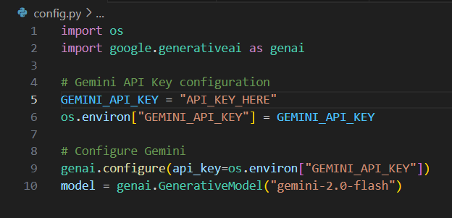

**Explanation:**

* The model gemini-2.0-flash is lightweight yet highly capable of generating quick, relevant, and context-aware financial insights.
* It is optimized for multi-turn conversations, structured responses, and natural financial explanations.
* Loading API keys via environment variables prevents unintentional exposure and supports easier cloud deployment later.

With this setup, the Gemini model becomes the **AI core** that powers personalized advice, dynamic text generation, and intelligent recommendations across the app.

**Milestone 3: Core Functional Modules**

The application follows a **modular structure**, promoting reusability and better organization. Each file serves a specific functional purpose within the ecosystem.

**Activity 1: Financial Data Analysis (finance_analysis.py)**

This module performs core financial computations by processing user inputs such as income, expenses, and debts. It calculates vital metrics like savings ratio, debt ratio, and emergency fund requirements, serving as the analytical foundation for all AI decisions.

The calculations transform raw numbers into meaningful data that the AI model can interpret, ensuring accuracy and contextual understanding.

**Code Snippet:**

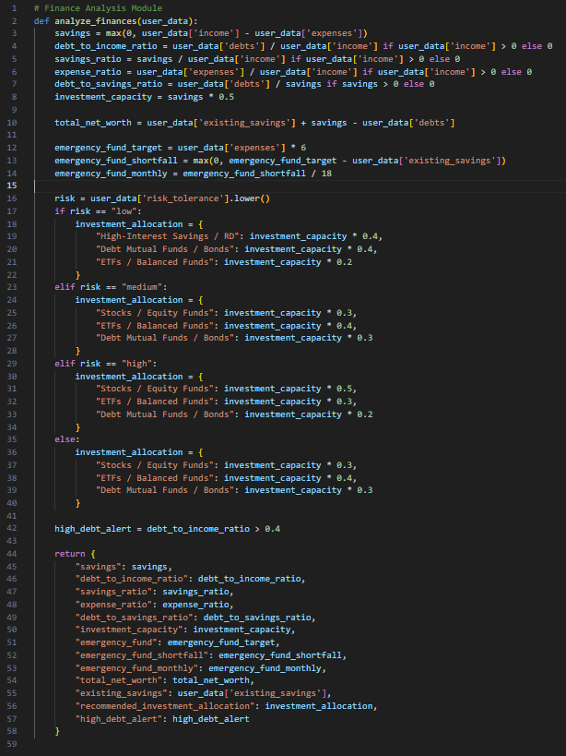

**Activity 2: AI Financial Guidance (ai_advisor.py)**

This is the intelligence center of the project. It communicates directly with Gemini and transforms structured data into natural-language financial guidance. By analyzing both user input and computed metrics, it can generate context-specific strategies such as budget optimization, debt reduction, and investment planning.

| **Function** | **Purpose** |
| --- | --- |
| generate_financial_advice() | Provides holistic, AI-generated advice based on income, savings, and goals. |
| generate_goal_plan() | Creates specific, step-by-step goal plans (e.g., retirement or education funds). |
| finance_chatbot_response() | Enables interactive, AI-powered conversations for ongoing financial queries. |

**Code Snippet (Financial Advisor):**

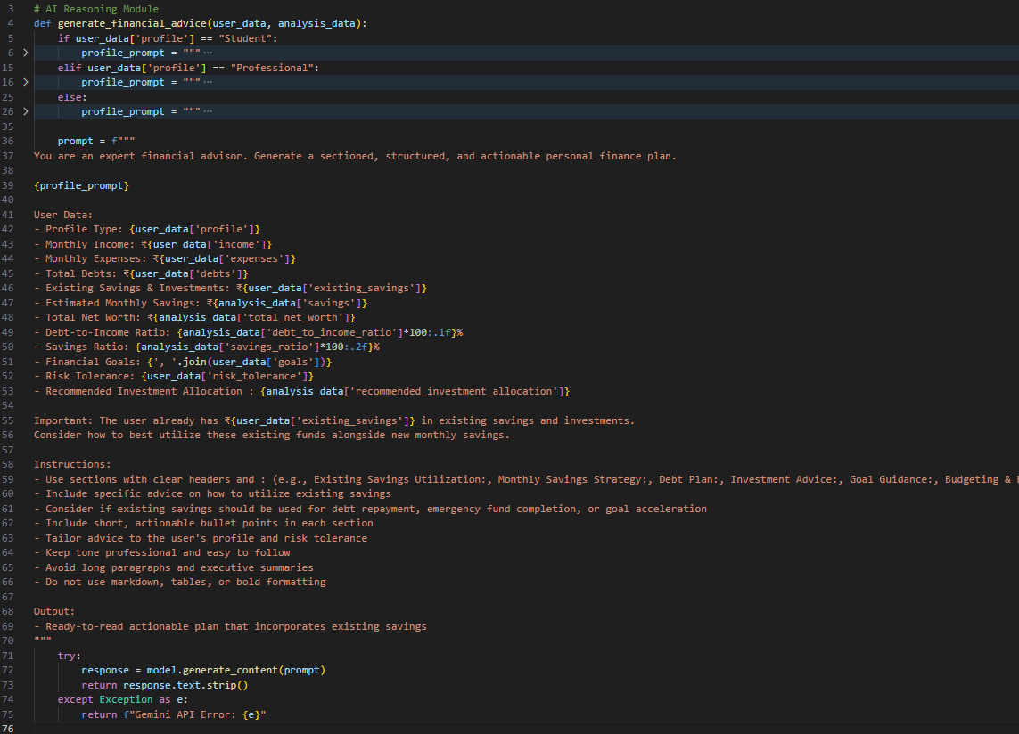

**Code Snippet (Advanced Goal-Oriented Financial Advisor):**

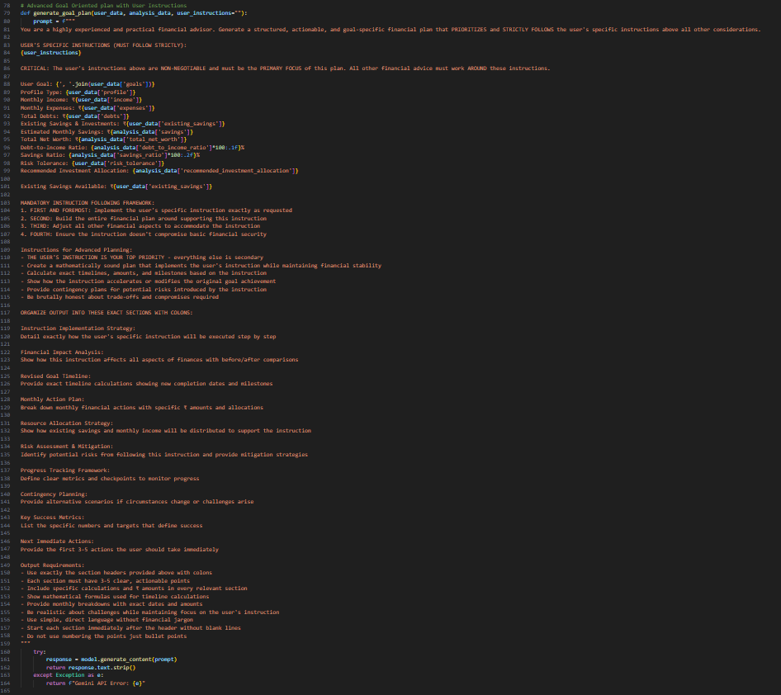

**Code Snippet (Financial Chabot):**

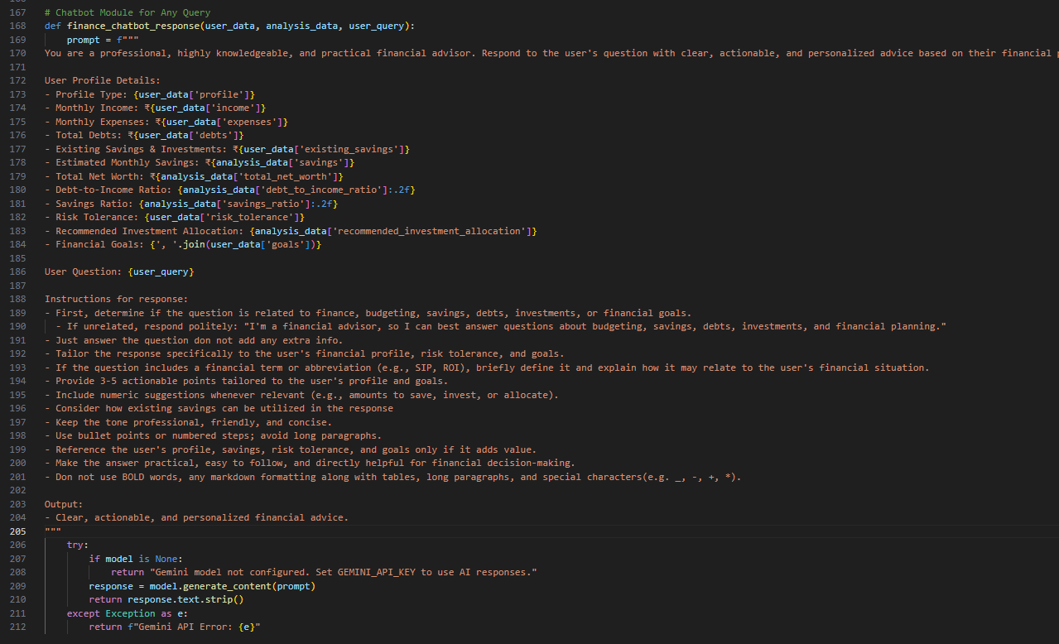

Each response is designed to feel personal, data-driven, and conversational, enabling users to understand complex financial ideas in simple language.

**Activity 3: Data Visualization (visualization.py)**

This component converts financial numbers into visually meaningful charts and graphs. Visualizations play a vital role in helping users grasp spending trends, savings ratios, and overall financial stability at a glance.

The module uses Matplotlib and Seaborn to create clear, professional visuals that complement AI explanations.

**Code Snippet:**

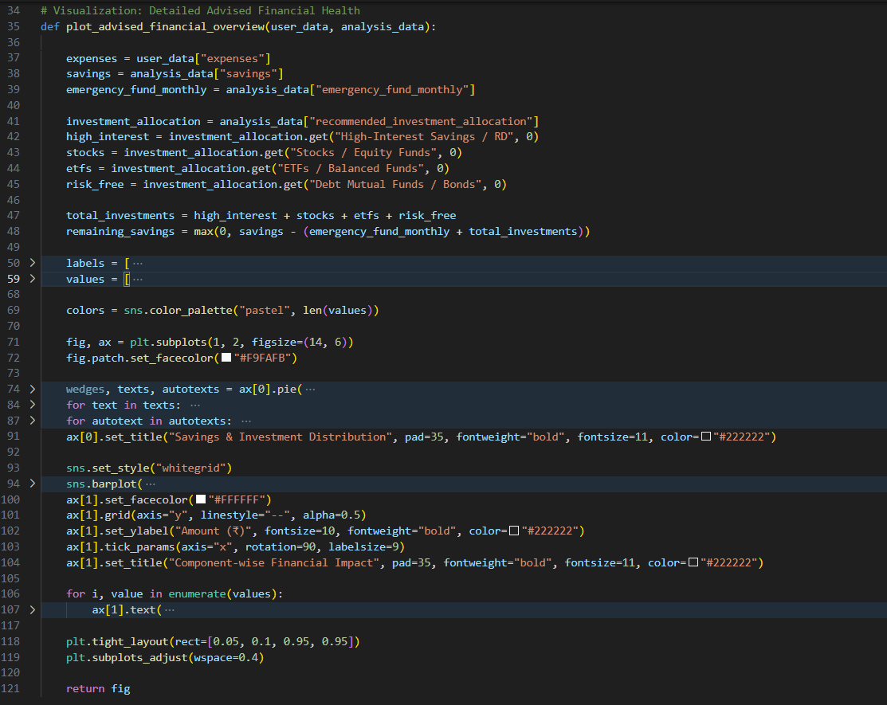

**Features:**

* Pie charts comparing income allocation between savings and expenses.
* Bar graphs representing monthly savings performance.
* Ratio indicators visualizing debt-to-income health.

This helps users understand not just what their financial status is, but why it looks that way.

**Activity 4: Helper Functions (utils.py)**

Utility functions simplify repetitive formatting and enhance the presentation of AI-generated advice. They ensure the information appears structured, polished, and easy to read on the Streamlit interface.

| **Function** | **Description** |
| --- | --- |
| split_advice_sections() | Splits lengthy AI responses into separate cards for better readability. |
| split_goal_sections() | Formats and organizes goal-oriented strategies neatly within the app layout. |

**Code Snippet:**

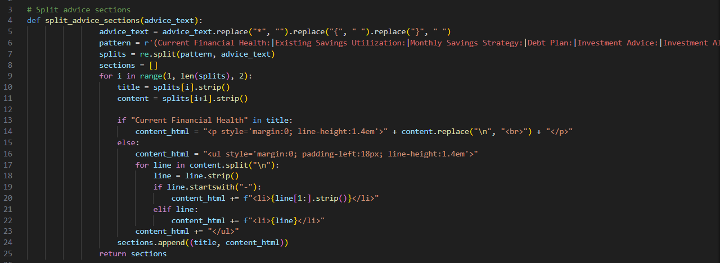

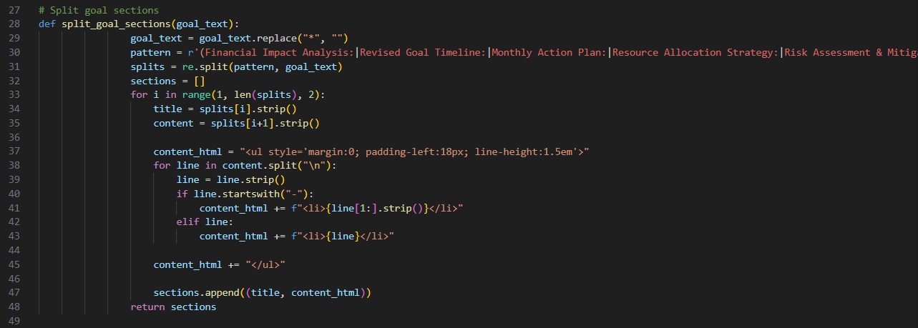

These utilities maintain consistency in tone, layout, and readability, making the output user-friendly and professional.

**Milestone 4: Streamlit Frontend**

To create a visually appealing, fully interactive financial dashboard that allows users to input, analyse, and visualize financial data with ease. The frontend bridges the AI logic with the user, providing a smooth, guided experience through each stage of financial assessment.

**Activity 1: Page Setup**

Defines the structure, layout, and design of the web interface using Streamlit.  
The homepage introduces the AI Financial Advisor, explains its purpose, and presents the user with intuitive navigation sections.

**Code Snippet:**

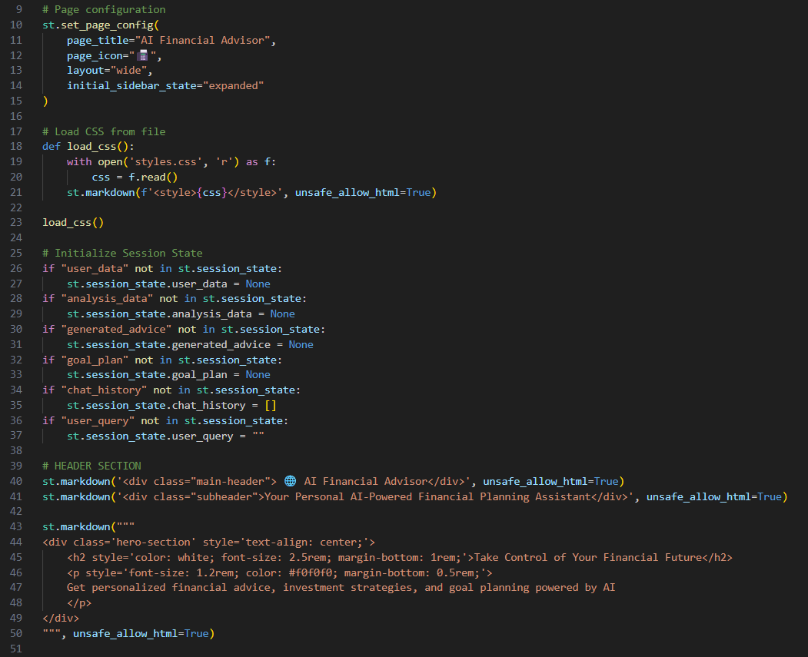

**Activity 2: Sidebar Input System**

The sidebar acts as a data entry panel where users provide all financial details.  
This includes their monthly income, expenses, savings, debts, and specific financial goals. Based on this data, the system performs in-depth analysis and generates AI-driven insights instantly.

**Code Snippet:**

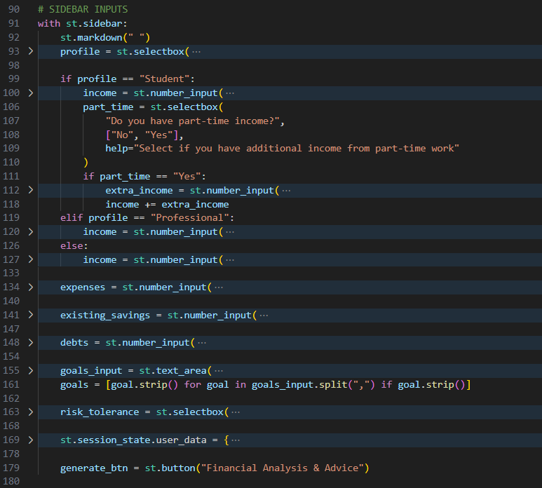

Each input is validated for correctness to ensure accurate results and prevent calculation errors.

**Activity 3: Financial Summary & Visualization**

Once user data is submitted, the system displays a comprehensive financial summary. Metrics such as savings ratio, investment potential, and debt health are presented through cards, progress bars, and charts.

**Code Snippet:**

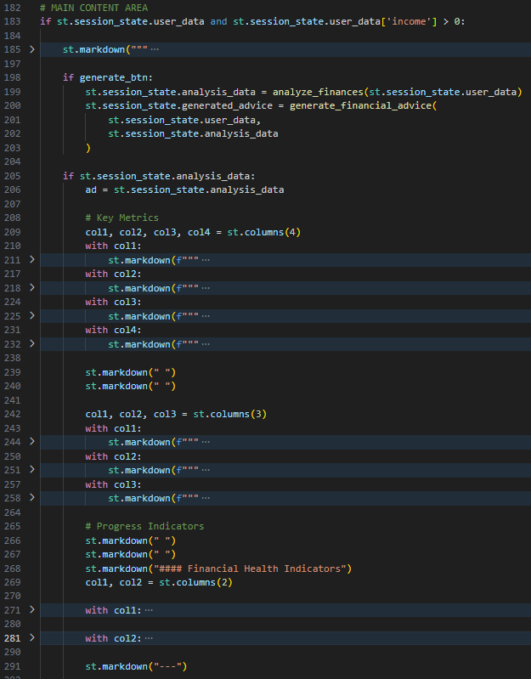

Visualizations not only help users identify areas of concern but also motivate them to achieve better financial habits through clear, visual progress tracking.

**Activity 4: AI Chatbot Section**

The chatbot serves as a **virtual financial consultant**, offering real-time responses to user queries. It provides data-backed, conversational advice tailored to each user’s input, using the same Gemini model.

**Code Snippet:**

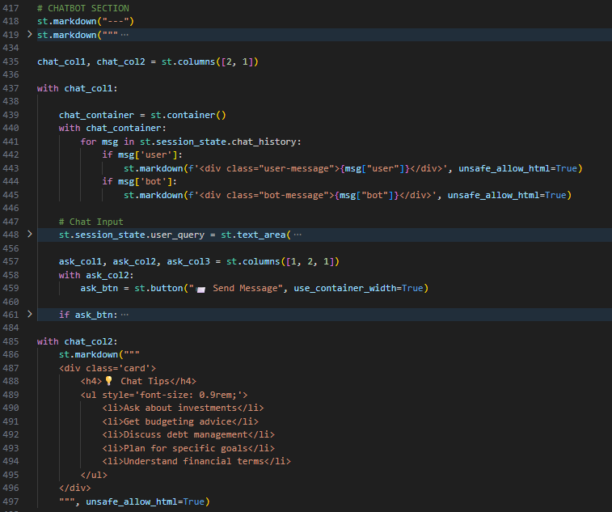

Users can discuss specific financial concerns, compare investment options, or plan for long-term goals interactively.

**Activity 5: Goal-Oriented and Advanced Planning**

This feature allows users to set and pursue personalized financial goals such as buying a home, saving for education, or building an emergency fund. The Gemini model generates customized action steps, including budgeting suggestions and investment allocations.

**Code Snippet:**

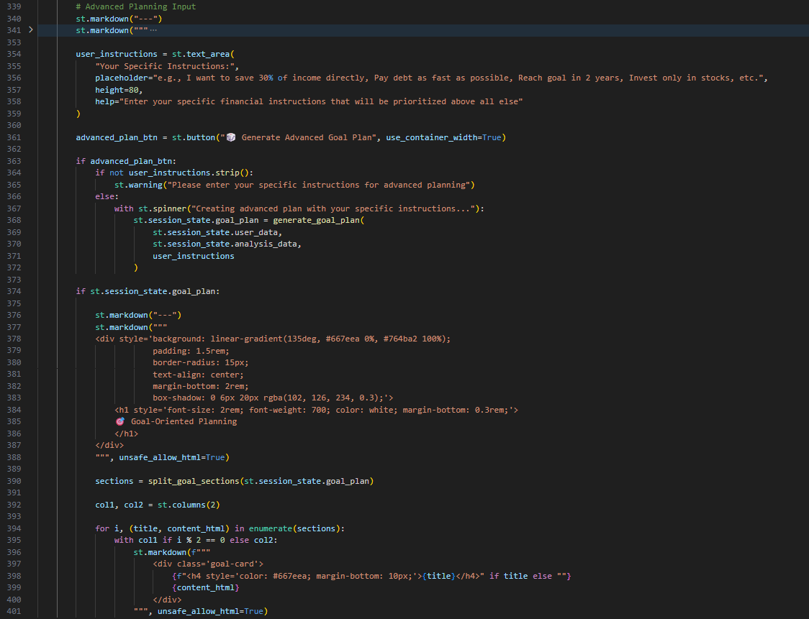

It ensures that every goal is supported by practical, measurable, and time-bound strategies.

**Activity 6: User Interface Highlights**

The UI combines professional design with simplicity:

* Gradient-colored headings for each section
* Clear metrics and icons for financial parameters
* Chatbox with alternating AI/user message design
* Organized goal cards for actionable insights

The interface enhances the overall user experience, making complex financial data feel approachable and engaging.

**Milestone 5: Model Deployment**

This milestone involves running and hosting the Streamlit app.

**Activity 1: Running the Application Locally**

To start the Streamlit app locally:

streamlit run app.py

This will launch the web interface in the default browser at:

http://localhost:8501

**Code snippet:**

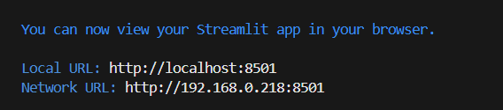

**Activity 2: Online Access**

You can optionally use **Localtunnel** or **Ngrok** on colab to expose your local Streamlit app to the internet for public access during demonstrations.

Example:

!npm install -g localtunnel

!streamlit run app.py & npx localtunnel --port 8501

**Output Preview**

**Output 1: Streamlit User Interface**

* Sidebar for User Financial Inputs and Configuration

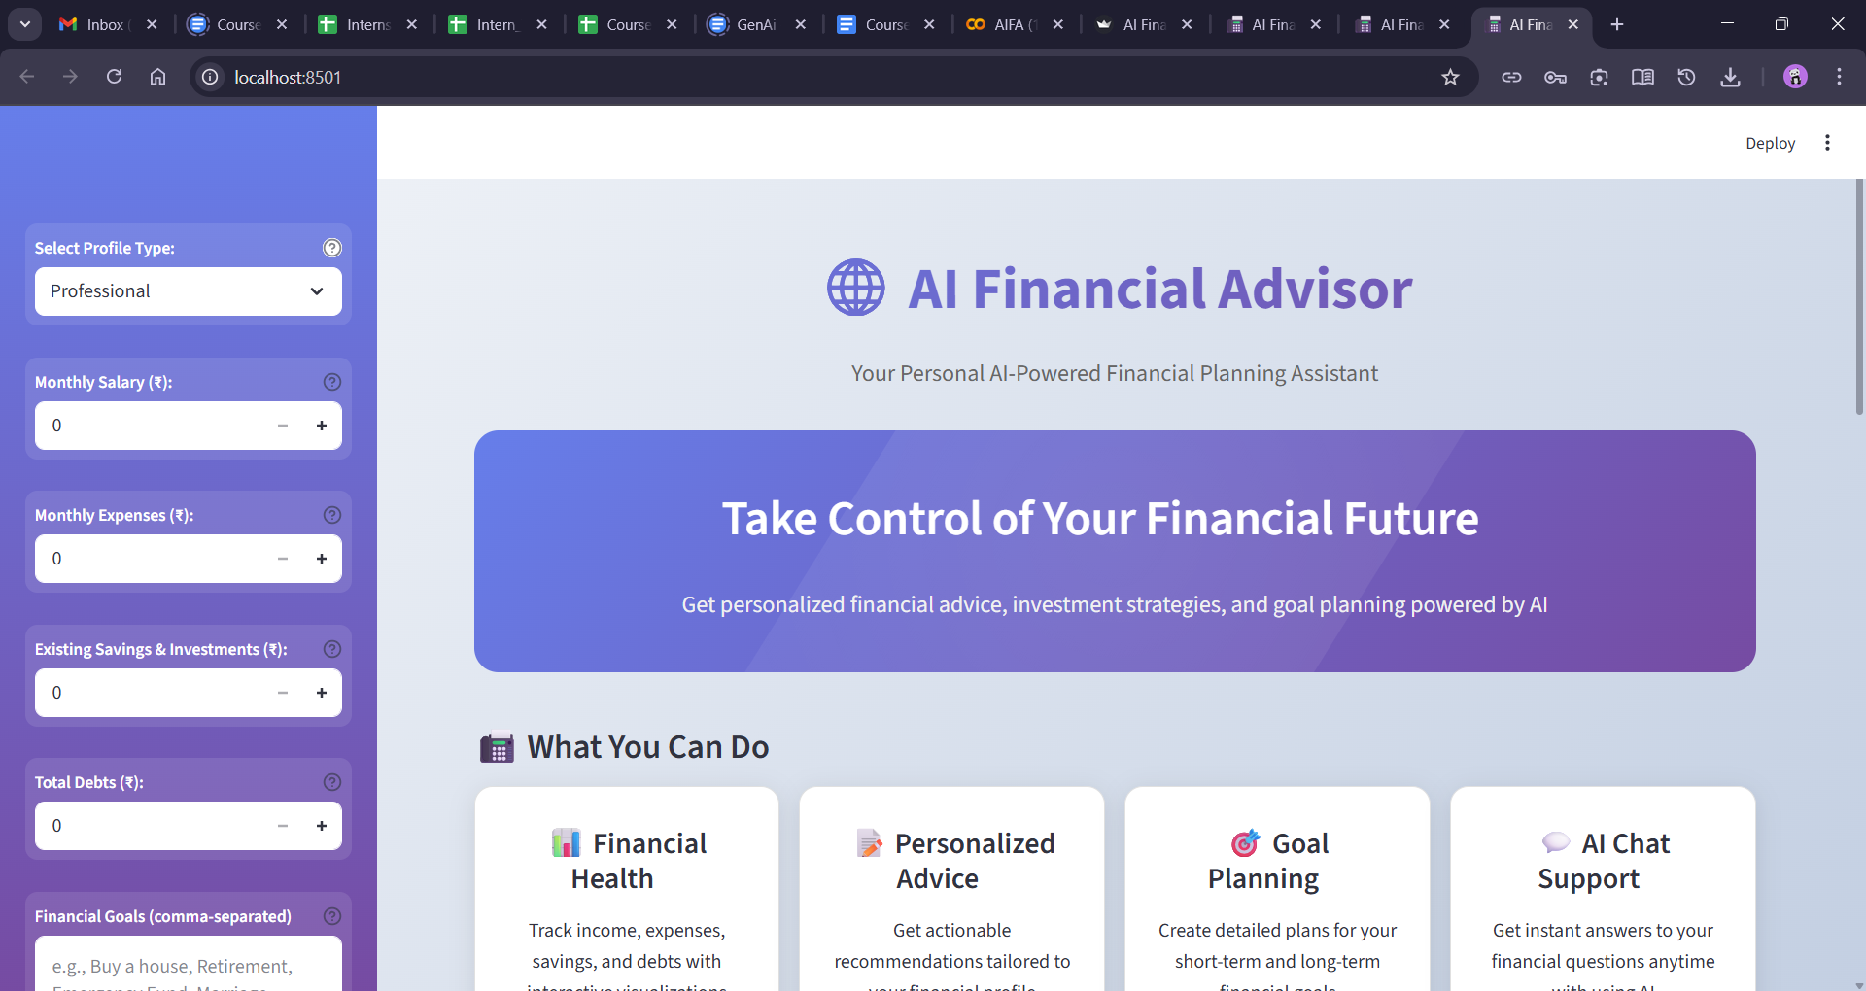

* Central Area Displaying Financial Insights and AI Advice

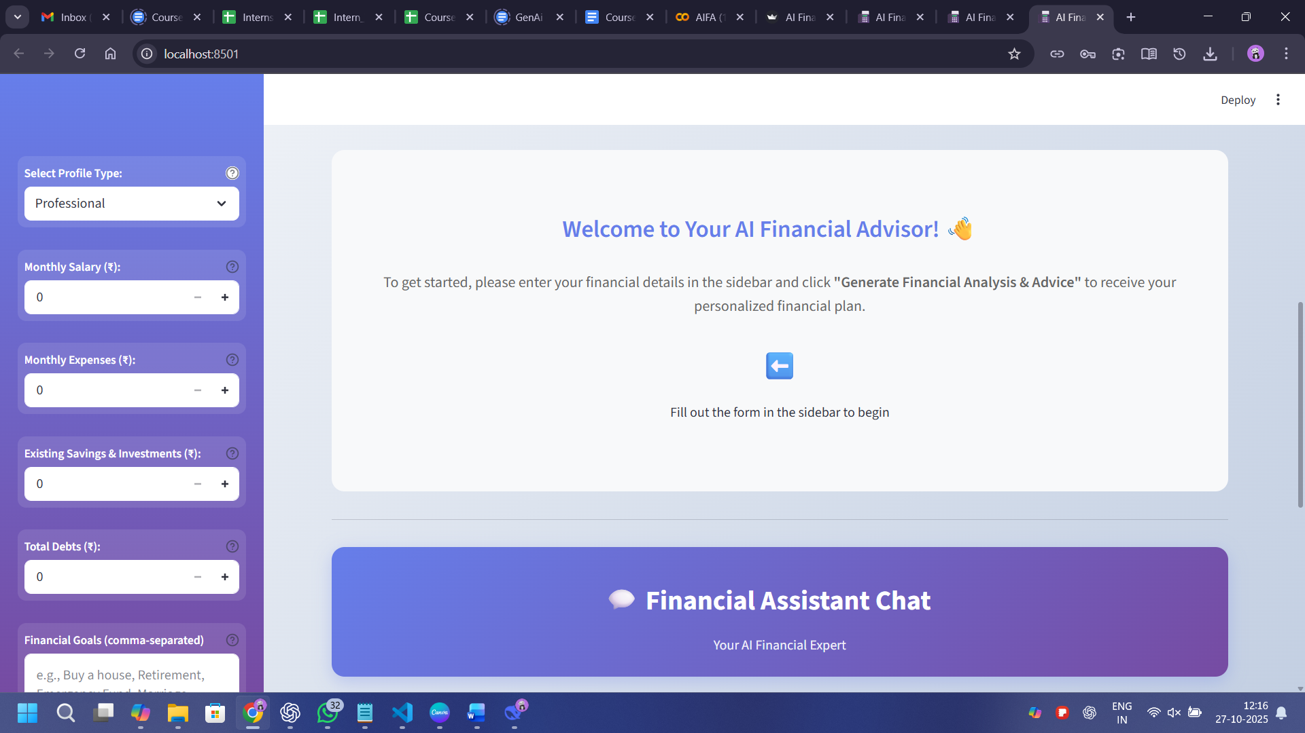

* Interactive Buttons for Analysis and AI Response Generation

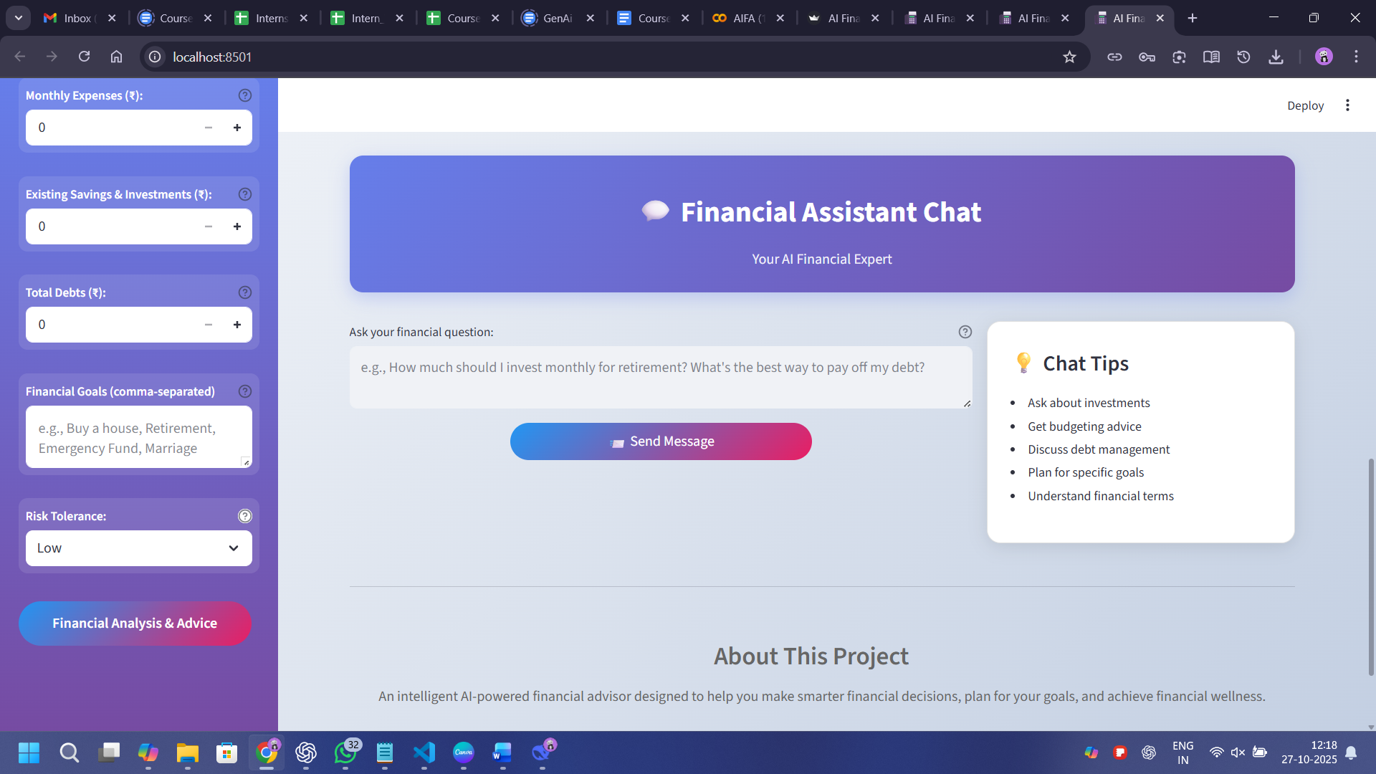

**Output 2: AI-Generated Financial Insights and Reports**

* Personalized AI Financial Recommendations

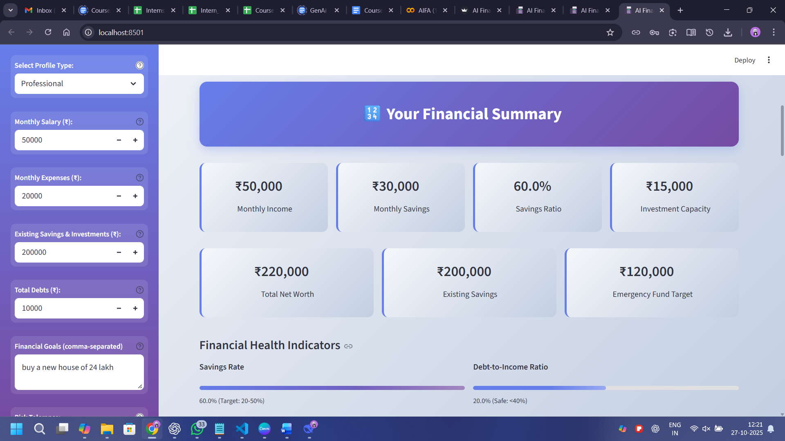

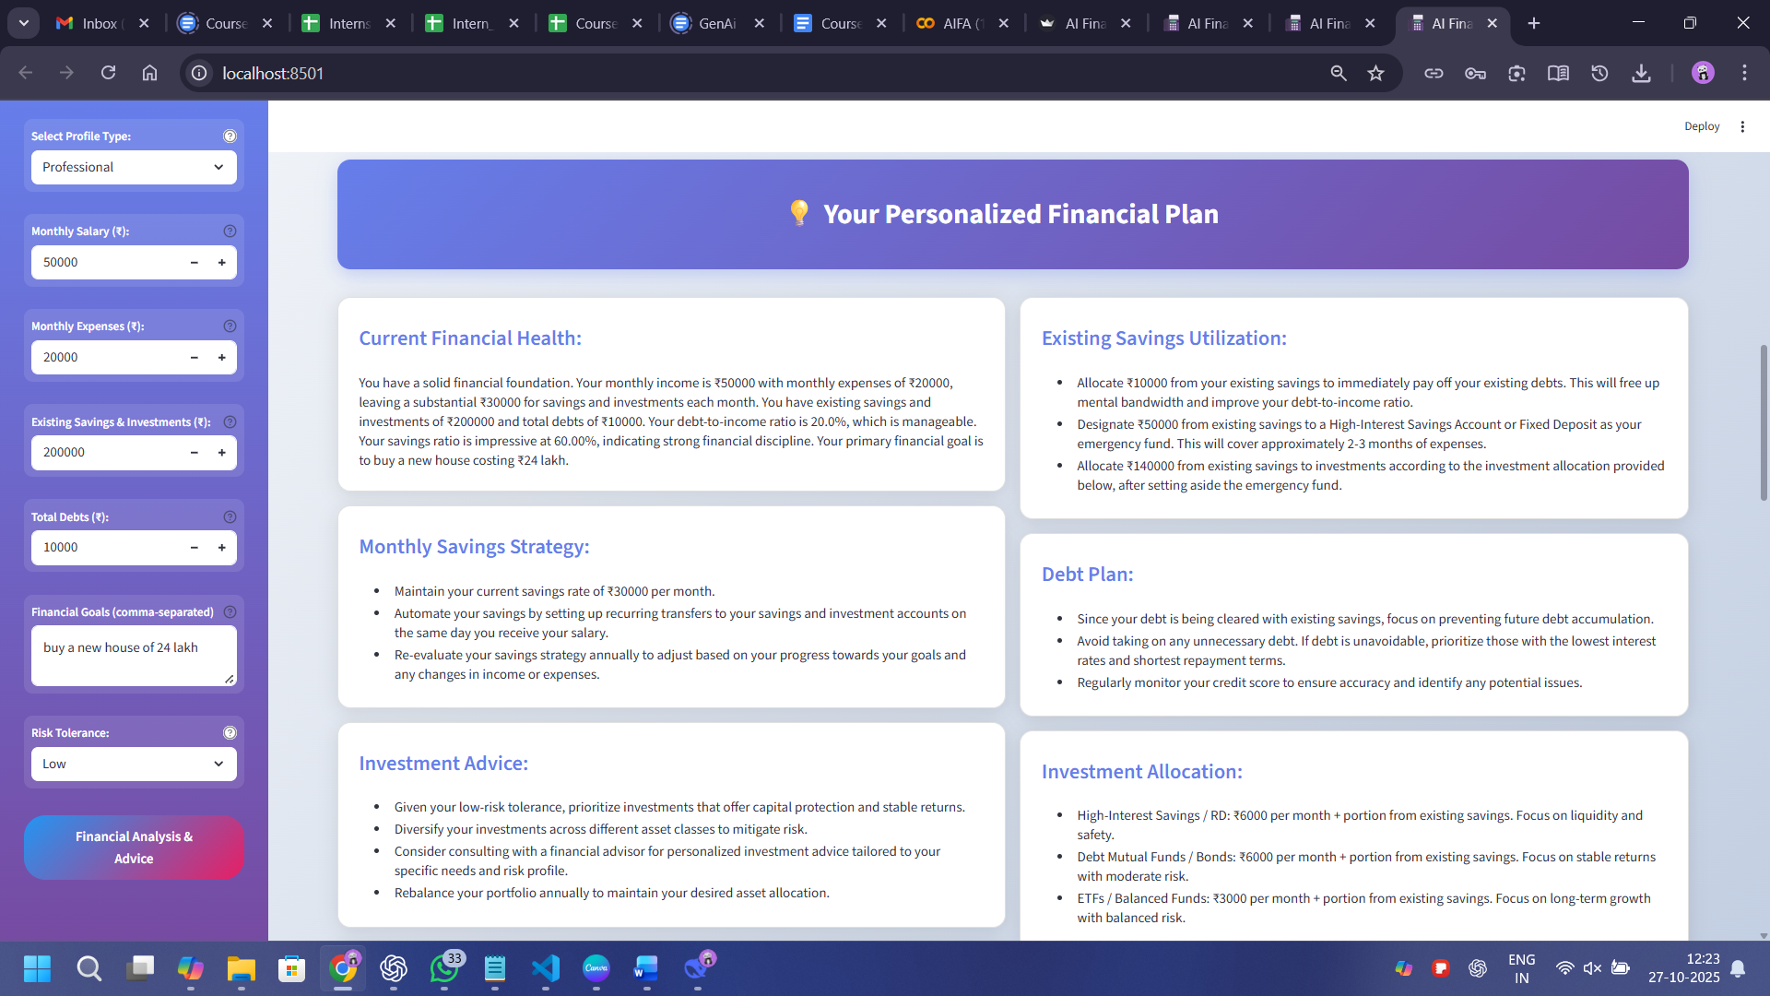

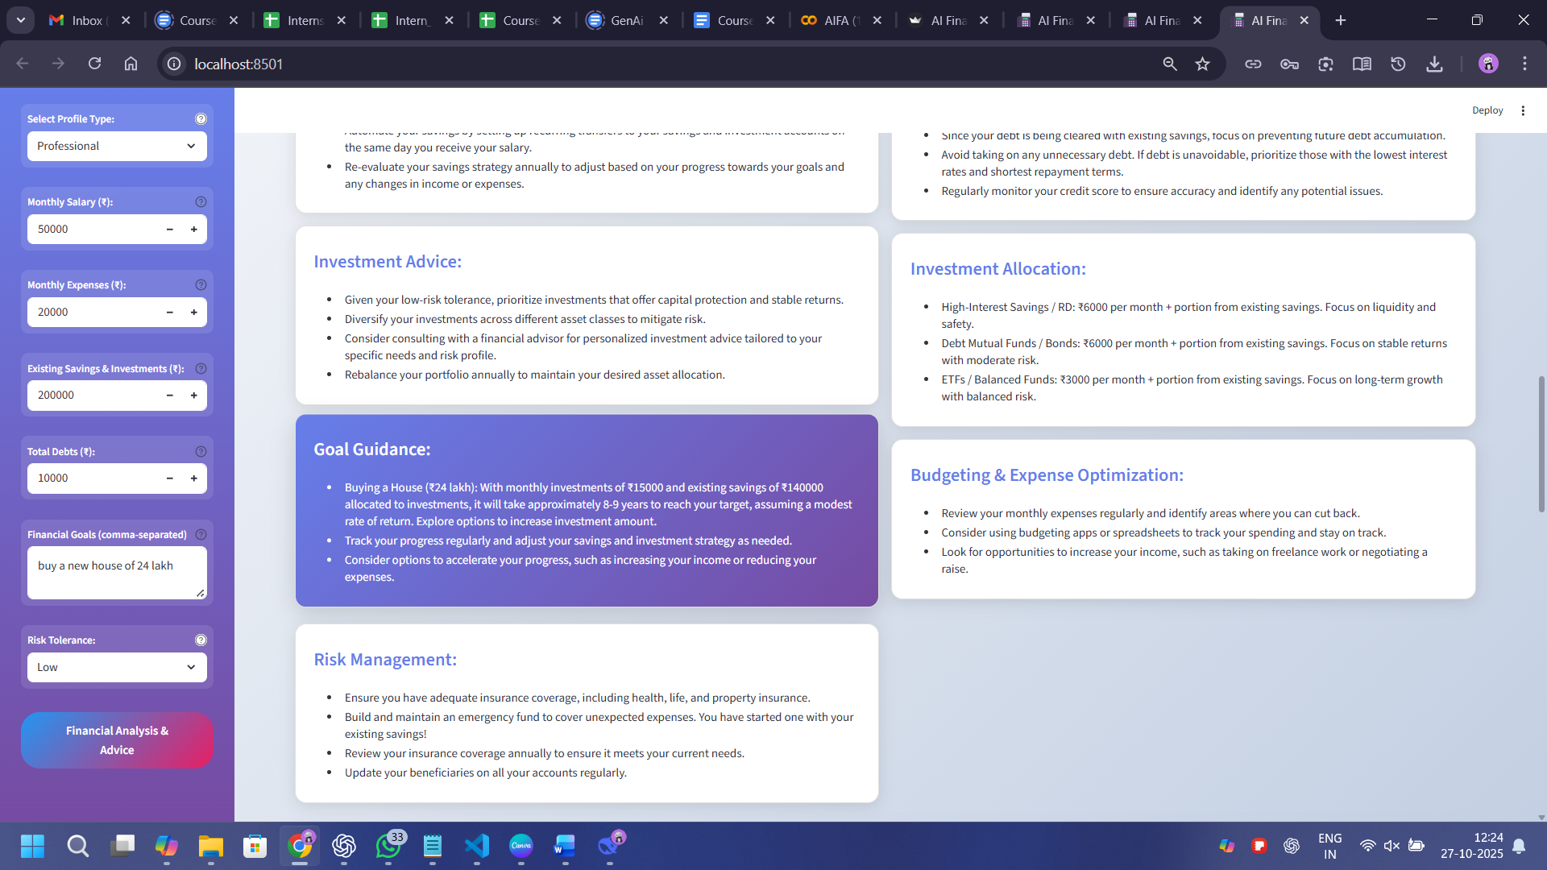

* Visual Financial Report

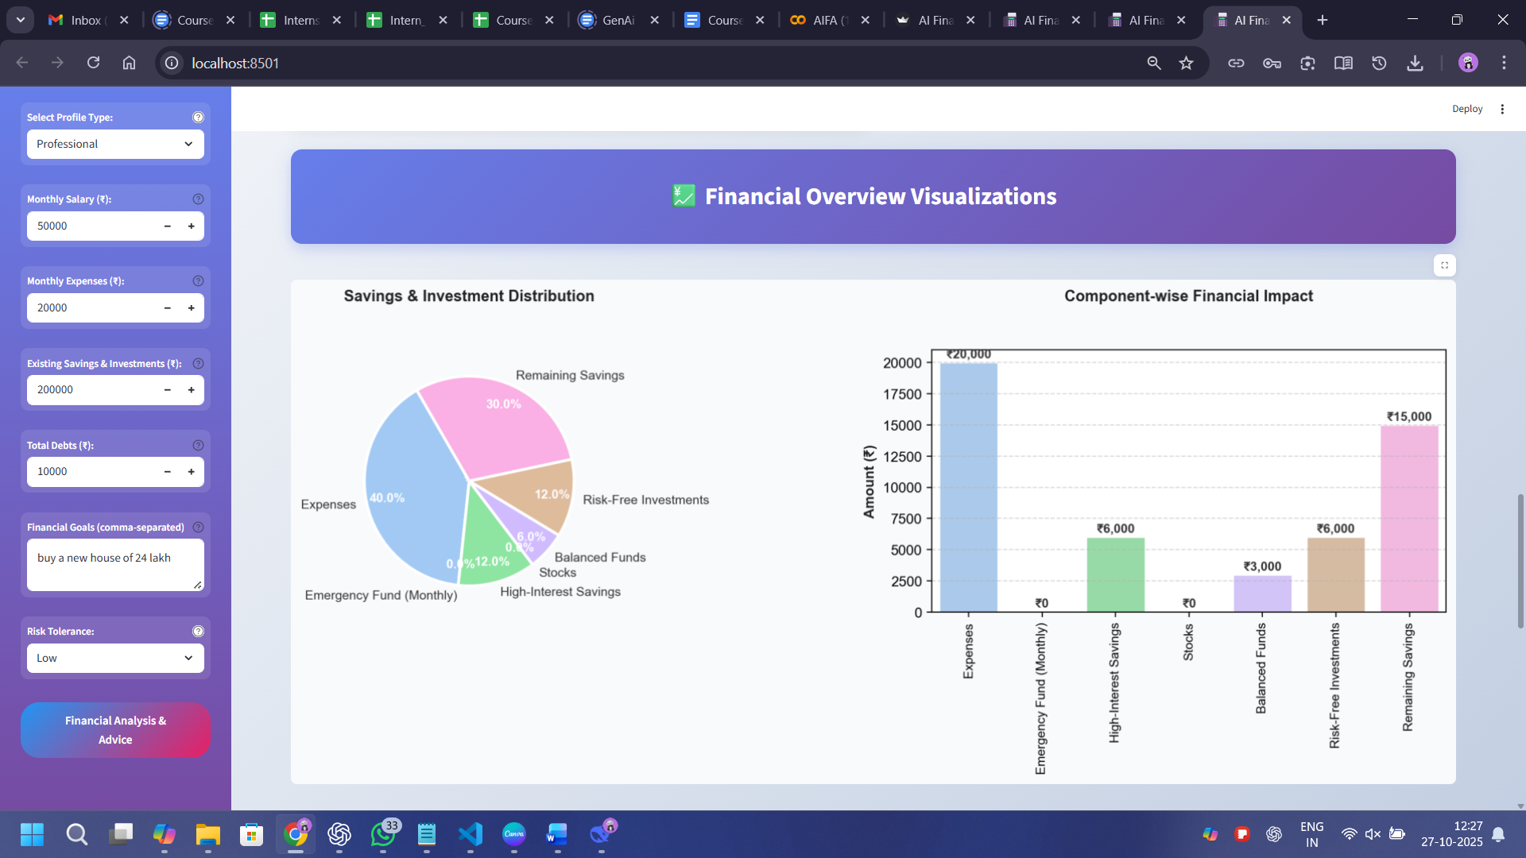

* Goal-Based Financial Plans

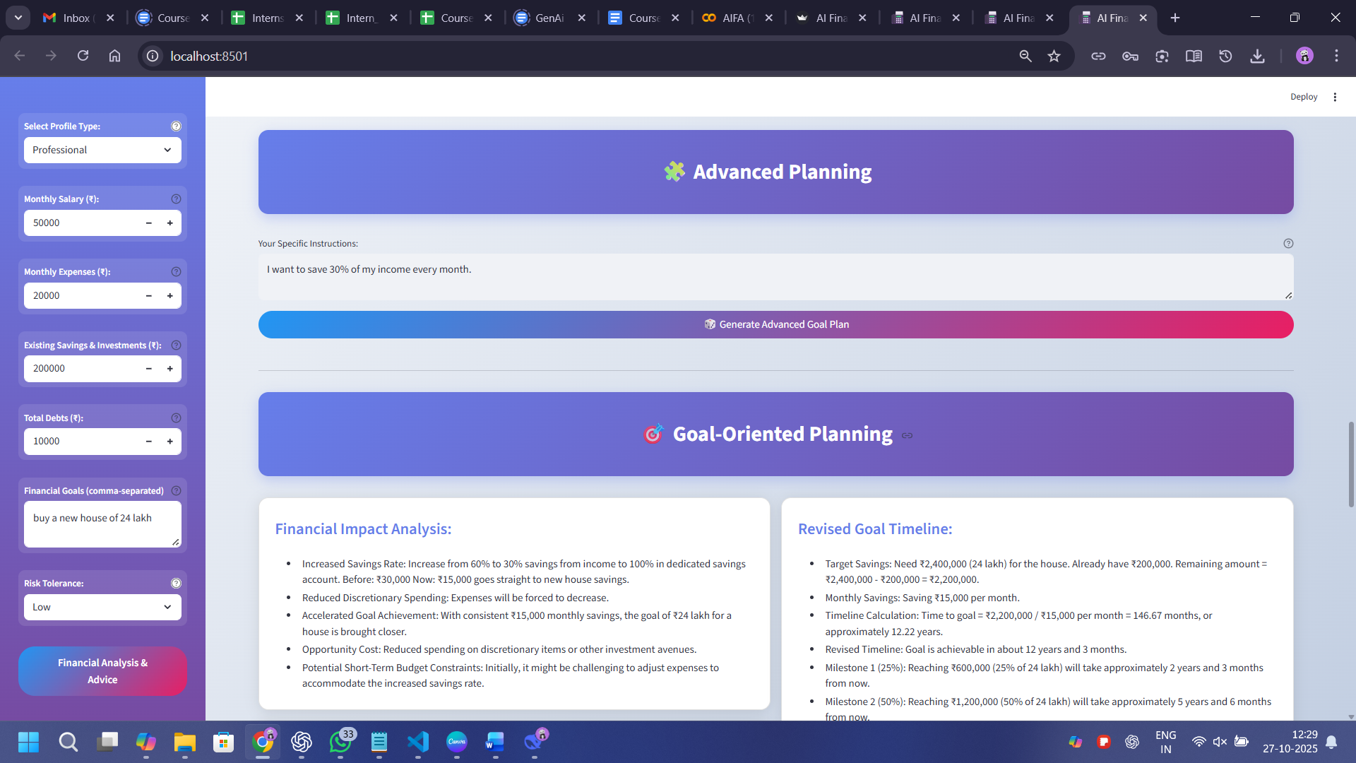

* Interactive Financial Chatbot

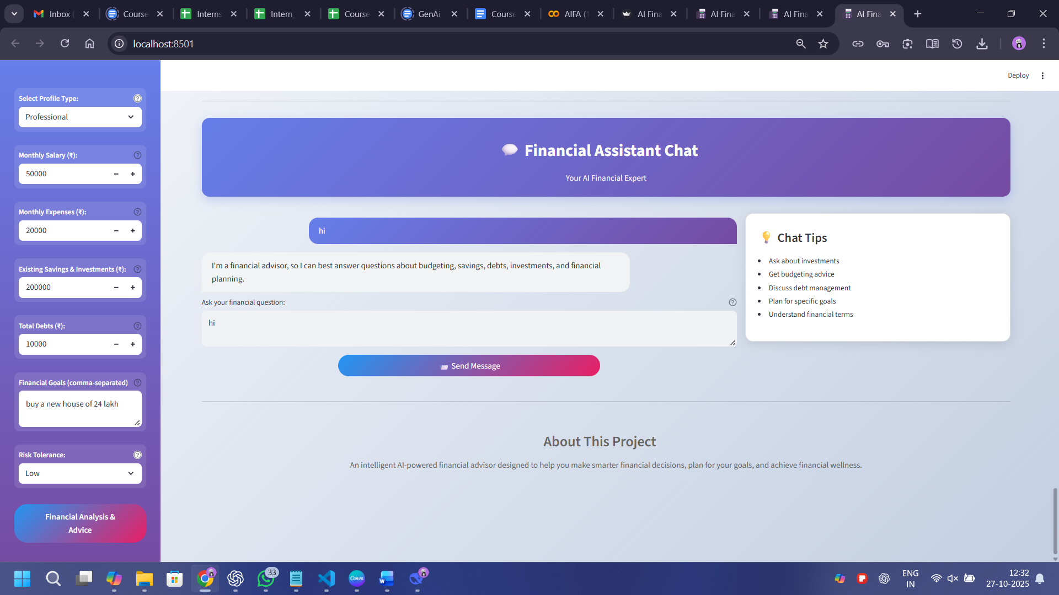

**Conclusion**

The AI Financial Advisor (AIFA) redefines the way individuals manage and plan their finances. By combining the analytical power of AI-driven insights with Streamlit interactive interface, it empowers users to make informed financial decisions with clarity and confidence.

This project showcases the seamless integration of Google Gemini’s generative intelligence with robust data analysis and visualization tools, delivering personalized advice, goal planning, and real-time financial support.

With future upgrades such as Live stocks/ETF data integration, automated portfolio optimization, and AI-powered investment forecasting, AIFA has the potential to evolve into a comprehensive digital financial companion helping users achieve lasting financial stability and growth.